Computer Language Coding Concepts

Pointer to Pointer in a Diagram
A pointer to a pointer points out an object in the context of another parent.

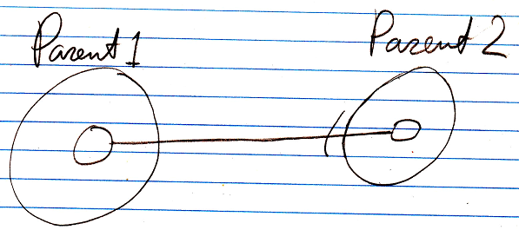

So a →1 related item does not have to contain an object reference. It can also also contain a reference to yet another →1 related item inside another parent. In that case, a related item is a pointer to a pointer. So instead of assigning an object to a related item, you assign a related item to a related item. A pointer to a pointer points out an object in the context of another parent.

Instead of pointing to a →1 related item, you can just as well point to a →n related list item.

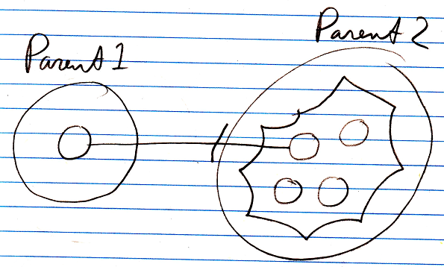

Pointing to another parent’s related item, means that the other parent has control over the eventual target pointed at. This is exactly what a pointer to pointer is applied for: giving another parent control over the eventual target pointed at.

When a related item points to a related item, that related item can again point to a related item, and so on.

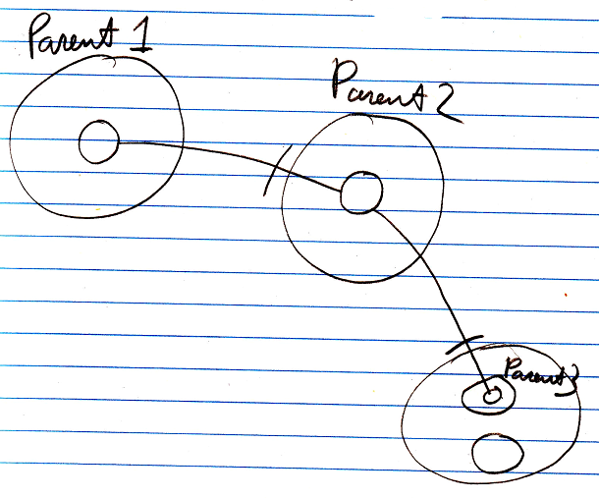

That’s how you create multiple pointer redirections.

So Parent 1 delegates its sub-object to Parent 2, granting Parent 2 control over the eventual target pointed at, which Parent 2 does, by deciding the eventual target is a related item inside Parent 3.
Parent 1 gives Parent 2 control the eventual target pointed at.

Synonyms for pointers to pointers are:

- Pointer to a related item
- Related item pointing to another related item
- Reference to an object reference

The system members for controlling pointers to pointers are covered by the article:

- Pointer to Pointer Get & Set

See also: System Objects

Author & Copyright: Jan-Joost van Zon Date: July 18, 2008 – July 23, 2009 Location: Oosterhout, The Netherlands Status: Finished

Ideas
Pointers,
2008-08

When you pass a property as a byref argument, and the procedure reads and writes from the byref parameter, you want the property get and set to be called. Does that require a pointer to a pointer to a pointer or what?
> No, just a pointer to a related object.

JJ

